Homework HA 8.6

# By: Shaya Engelman, Julia Ferris, Amanda Fox, and Jean Jimenez

06/15/2024

Use R to simulate and plot some data from simple ARIMA models.

1. **Use the following R code to generate data from an AR(1) model with** Φ1 **= 0.6 and variance = 1. The process starts with y1 = 0.**

```{r}

set.seed(85)

y <- ts(numeric(100))

e <- rnorm(100)

for(i in 2:100)

y[i] <- 0.6*y[i-1] + e[i]

```

**Produce a time plot for the series. How does the plot change as you change autoregressive operator 1?**

This is the time plot.

```{r}

plot(y, type = "l", main = "Time Plot of Series", xlab = "Time", ylab = "Value")

```

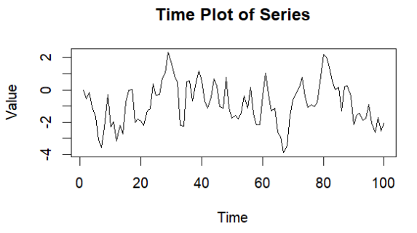

Next, the autoregressive operator was changed to 0.25, 1, and 2. The plots of these three variations are below. As you can see from the results, lowering the autoregressive operator slightly caused the values to appear a bit more random. A pattern was not obvious. When increasing the value to 1, the graph appeared to have a slight cyclical pattern. When increasing the value to 1.5, an obvious curve appeared. The values began around 0 and then experienced an exponential change in the positive direction.

```{r}

set.seed(40)

y <- ts(numeric(100))

e <- rnorm(100)

for(i in 2:100)

y[i] <- 0.25*y[i-1] + e[i]

plot(y, type = "l", main = "Time Plot of Series - Variation 1", xlab = "Time", ylab = "Value")

y <- ts(numeric(100))

e <- rnorm(100)

for(i in 2:100)

y[i] <- 1*y[i-1] + e[i]

plot(y, type = "l", main = "Time Plot of Series - Variation 2", xlab = "Time", ylab = "Value")

y <- ts(numeric(100))

e <- rnorm(100)

for(i in 2:100)

y[i] <- 1.5*y[i-1] + e[i]

plot(y, type = "l", main = "Time Plot of Series - Variation 3", xlab = "Time", ylab = "Value")

```

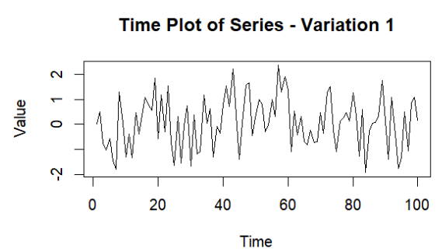 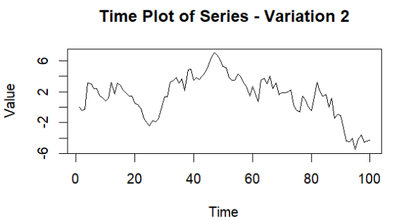

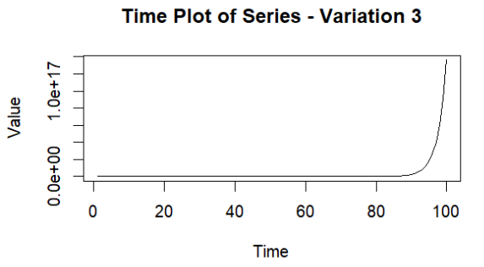

1. **Write your own code to generate data from an MA(1) model with θ1 = 0.6 variance = 1.**

```{r}

set.seed(25)

e <- rnorm(100, mean = 0, sd = sqrt(1))

y <- ts(numeric(100))

for(i in 2:100) {

y[i] <- e[i] + 0.6 * e[i-1]

}

```

1. **Produce a time plot for the series. How does the plot change as you change theta 1?**

This is the plot.

```{r}

# Plot the time series

plot(y, type = "l", main = "Time Plot of Moving Average Series", xlab = "Time", ylab = "Value")

```

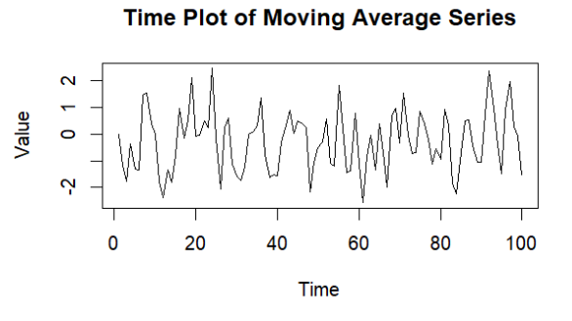

To answer the second part of this question, values 0.25, 1, and 1.5 were used again. The plots with these three variations of theta are shown below. The graphs did not appear to change in any significant way.

```{r}

set.seed(25)

e <- rnorm(100, mean = 0, sd = sqrt(1))

y <- ts(numeric(100))

for(i in 2:100) {

y[i] <- e[i] + 0.25 * e[i-1]

}

plot(y, type = "l", main = "Time Plot of Moving Average Series - Vatiation 1", xlab = "Time", ylab

= "Value")

set.seed(25)

e <- rnorm(100, mean = 0, sd = sqrt(1))

y <- ts(numeric(100))

for(i in 2:100) {

y[i] <- e[i] + 1 * e[i-1]

}

plot(y, type = "l", main = "Time Plot of Moving Average Series - Variation 2", xlab = "Time", ylab

= "Value")

set.seed(25)

e <- rnorm(100, mean = 0, sd = sqrt(1))

y <- ts(numeric(100))

for(i in 2:100) {

y[i] <- e[i] + 1.5 * e[i-1]

}

plot(y, type = "l", main = "Time Plot of Moving Average Series - Variation 3", xlab = "Time", ylab

= "Value")

```

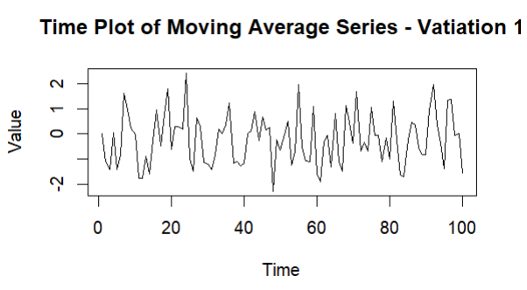 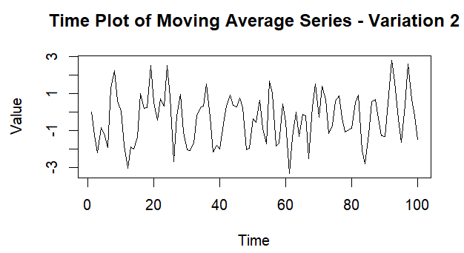

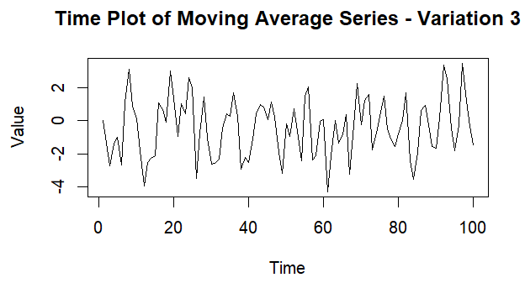

1. **Generate data from an ARMA(1,1) model with Φ1 = 0.6, θ1 = -0.6, and variance = 1.**

```{r}

set.seed(899)

e <- rnorm(100, mean = 0, sd = sqrt(1))

y <- ts(numeric(100))

for(i in 2:100) {

y[i] <- 0.6 * y[i-1] + e[i] + -0.6 * e[i-1]

}

```

1. **Generate data from an AR(2) model with Φ1 = -0.8, Φ2 = 0.3, and variance = 1. (These will give a non-stationary series.)**

```{r}

set.seed(101)

# Generate the white noise errors with the specified variance

e <- rnorm(100, mean = 0, sd = sqrt(1))

# Initialize the time series

y2 <- ts(numeric(100))

# Generate the AR(2) series

for(i in 3:100) {

y2[i] <- -0.8 * y2[i-1] + 0.3 * y2[i-2] + e[i]

}

```

1. **Graph the latter two series and compare them.**

The ARMA(1,1) graph appears to be random data without any obvious pattern. The AR(2) graph appears to gradually increase in height of the values in both the negative and y directions, and it appears to look like a crescendo in music. The first graph is stationary while the second graph is not.

```{r}

plot(y, type = "l", main = "Time Plot of ARMA(1,1) Series", xlab = "Time", ylab = "Value")

plot(y2, type = "l", main = "Time Plot of AR(2) Series", xlab = "Time", ylab = "Value")

```

